We are happy to introduce the **vistributions** package, a set of tools for  
visually exploring probability distributions.

**Installation**

# Install release version from CRAN

install.packages("vistributions")

# Install development version from GitHub

# install.packages("devtools")

devtools::install_github("rsquaredacademy/vistributions")

**Shiny App**

**vistributions** includes a shiny app which can be launched using

vdist_launch_app()

or try the live version [here](https://www.rsquaredcomputing.com/shiny/vistributions/).

Read on to learn more about the features of **vistributions**, or see the  
[vistributions website](https://vistributions.rsquaredacademy.com/) for  
detailed documentation on using the package.

**Tab Completion**

The common vdist_ prefix will trigger autocomplete, allowing you to see all  
**vistributions** functions:



In exploring statistical distributions, we focus on the following:

* what influences the shape of a distribution
* calculate probability from a given quantile
* calculate quantiles out of given probability

for the following distributions:

* Normal
* Binomial
* Chi Square
* F
* t

**Normal Distribution**

**Distribution Shape**

Visualize how changes in mean and standard deviation affect the shape of the  
normal distribution.

**Input**

* mean: mean of the normal distribution
* sd: standard deviation of the normal distribution

vdist_normal_plot(mean = 2, sd = 0.6)

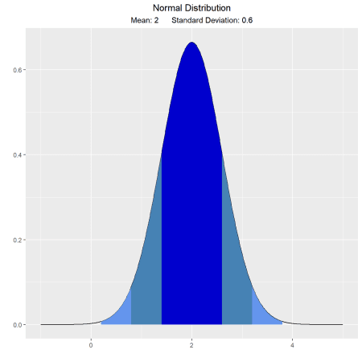

**Percentiles**

**Calculate and visualize quantiles out of given probability.**

**Input**

* probs: a probability value
* mean: mean of the normal distribution
* sd: standard deviation of the normal distribution
* type: lower/upper tail

Suppose X, the grade on a exam, is normally distributed with mean 60  
and standard deviation 3. The teacher wants to give 10% of the class an A.  
What should be the cutoff to determine who gets an A?

vdist_normal_perc(0.10, 60, 3, 'upper')

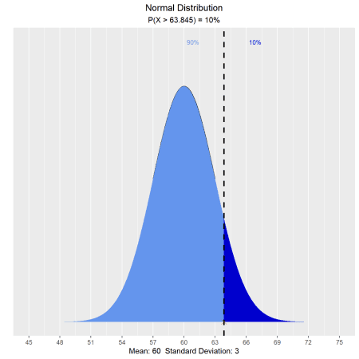

The teacher wants to give lower 15% of the class a D. What cutoff should the  
teacher use to determine who gets an D?

vdist_normal_perc(0.85, 60, 3, 'lower')

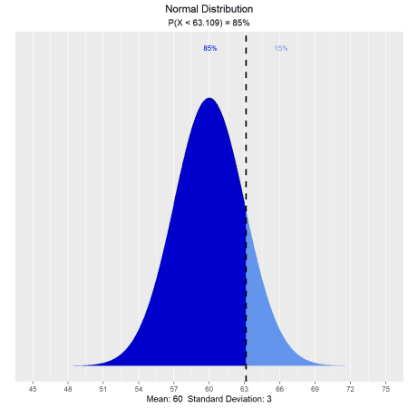

The teacher wants to give middle 50% of the class a B. What cutoff should the  
teacher use to determine who gets an B?

vdist_normal_perc(0.5, 60, 3, 'both')

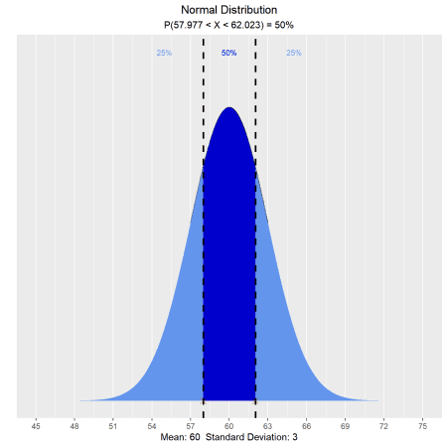

**Probabilities**

**Calculate and visualize probability from a given quantile**

**Input**

* perc: a quantile value
* mean: mean of the normal distribution
* sd: standard deviation of the normal distribution
* type: lower/upper/both tail

Let X be the IQ of a randomly selected student of a school. Assume X ~ N(90, 4).  
What is the probability that a randomly selected student has an IQ below 80?

vdist_normal_prob(80, mean = 90, sd = 4)

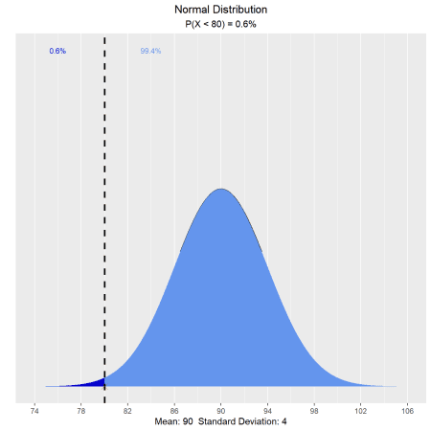

What is the probability that a randomly selected student has an IQ above 100?

vdist_normal_prob(100, mean = 90, sd = 4, type = 'upper')

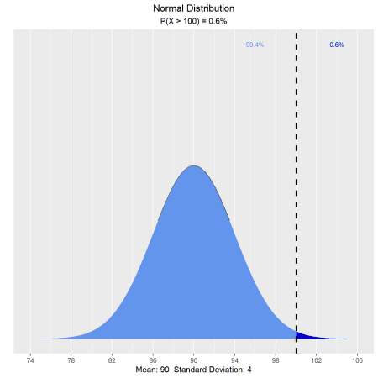

What is the probability that a randomly selected student has an IQ  
between 85 and 100?

vdist_normal_prob(c(85, 100), mean = 90, sd = 4, type = 'both')

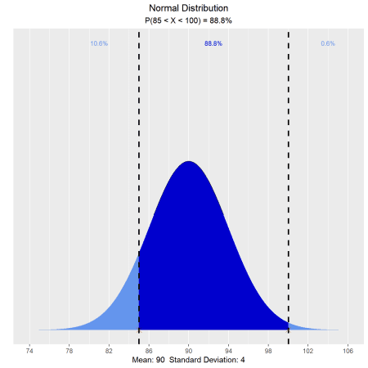

**Binomial Distribution**

**Distribution Shape**

Visualize how changes in number of trials and the probability of success affect  
the shape of the binomial distribution.

vdist_binom_plot(10, 0.3)

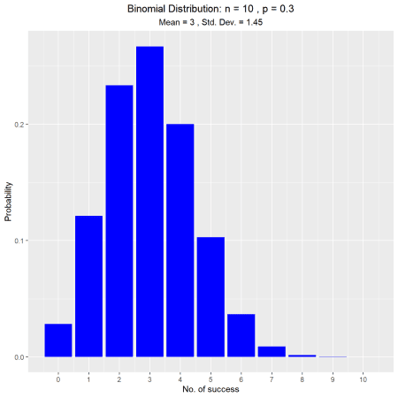

**Percentiles**

**Calculate and visualize quantiles out of given probability**

**Input**

* p: a single aggregated probability of multiple trials
* n: the number of trials
* tp: the probability of success in a trial
* type: lower/upper tail

vdist_binom_perc(10, 0.5, 0.05)

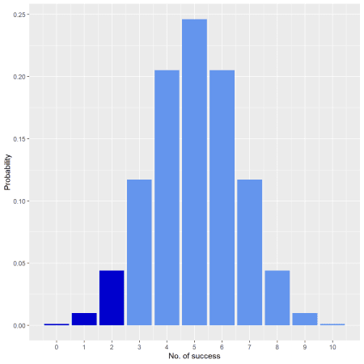

vdist_binom_perc(10, 0.5, 0.05, 'upper')

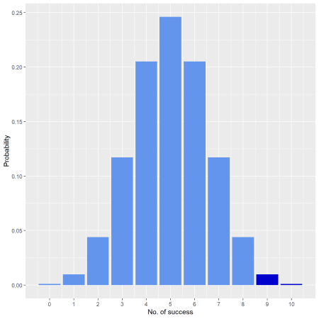

**Probabilities**

**Calculate and visualize probability from a given quantile**

**Input**

* p: probability of success
* n: the number of trials
* s: number of success in a trial
* type: lower/upper/interval/exact tail

Assume twenty-percent (20%) of Magemill have no health insurance. Randomly  
sample n = 12 Magemillians. Let X denote the number in the sample with no  
health insurance. What is the probability that exactly 4 of the 15 sampled  
have no health insurance?

vdist_binom_prob(12, 0.2, 4, type = 'exact')

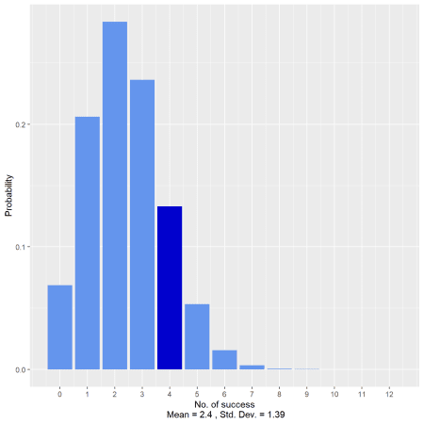

What is the probability that at most one of those sampled has no health  
insurance?

vdist_binom_prob(12, 0.2, 1, 'lower')

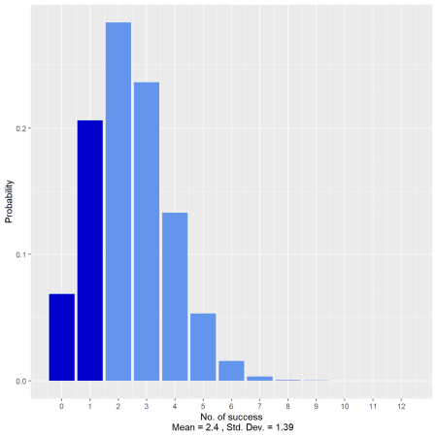

What is the probability that more than seven have no health insurance?

vdist_binom_prob(12, 0.2, 8, 'upper')

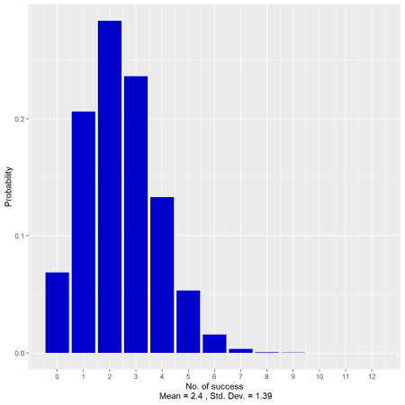

What is the probability that fewer than 5 have no health insurance?

vdist_binom_prob(12, 0.2, c(0, 4), 'interval')

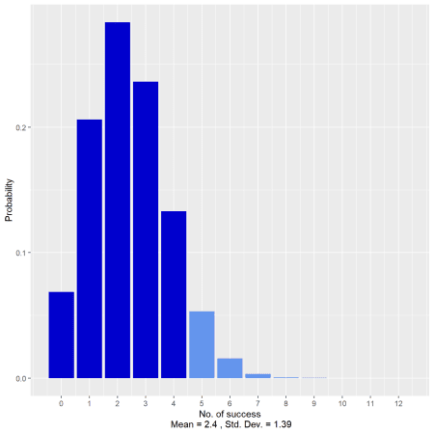

**Chi Square Distribution**

**Distribution Shape**

Visualize how changes in degrees of freedom affect the shape of the chi square  
distribution.

vdist_chisquare_plot(df = 5)

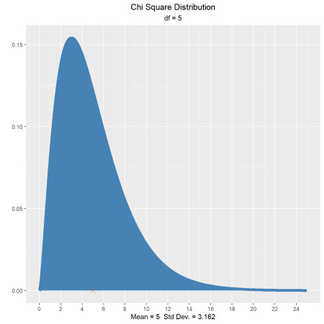

vdist_chisquare_plot(df = 5, normal = TRUE)

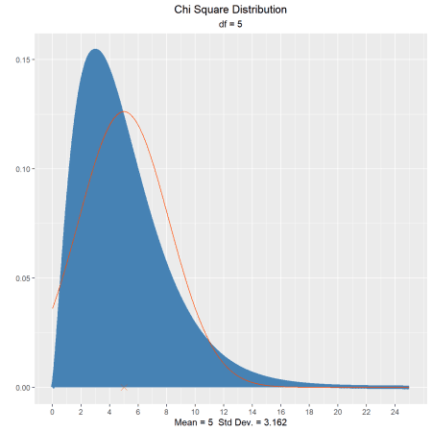

**Percentiles**

**Calculate quantiles out of given probability**

**Input**

* probs: a probability value
* df: degrees of freedom
* type: lower/upper tail

Let X be a chi-square random variable with 8 degrees of freedom. What is the  
upper fifth percentile?

vdist_chisquare_perc(0.05, 8, 'upper')

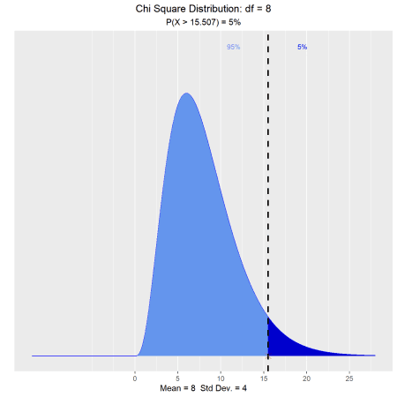

What is the tenth percentile?

vdist_chisquare_perc(0.10, 8, 'lower')

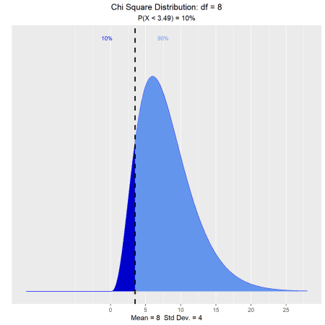

**Probability**

**Calculate probability from a given quantile.**

**Input**

* perc: a quantile value
* df: degrees of freedom
* type: lower/upper tail

What is the probability that a chi-square random variable with 12 degrees of  
freedom is greater than 8.79?

vdist_chisquare_prob(8.79, 12, 'upper')

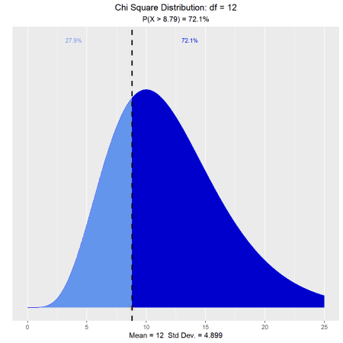

What is the probability that a chi-square random variable with 12 degrees of  
freedom is greater than 8.62?

vdist_chisquare_prob(8.62, 12, 'lower')

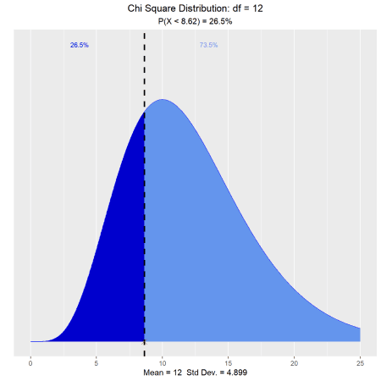

**F Distribution**

**Distribution Shape**

Visualize how changes in degrees of freedom affect the shape of the F  
distribution.

vdist_f_plot()

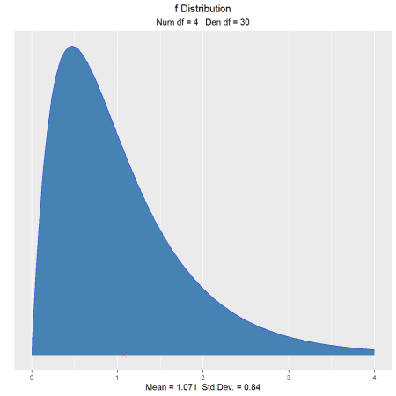

vdist_f_plot(6, 10, normal = TRUE)

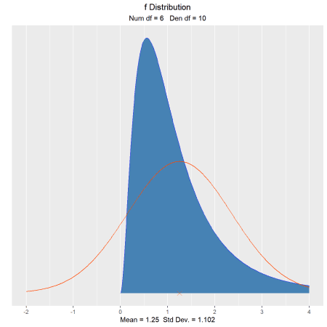

**Percentiles**

**Calculate quantiles out of given probability**

**Input**

* probs: a probability value
* num_df: nmerator degrees of freedom
* den_df: denominator degrees of freedom
* type: lower/upper tail

Let X be an F random variable with 4 numerator degrees of freedom and 5  
denominator degrees of freedom. What is the upper twenth percentile?

vdist_f_perc(0.20, 4, 5, 'upper')

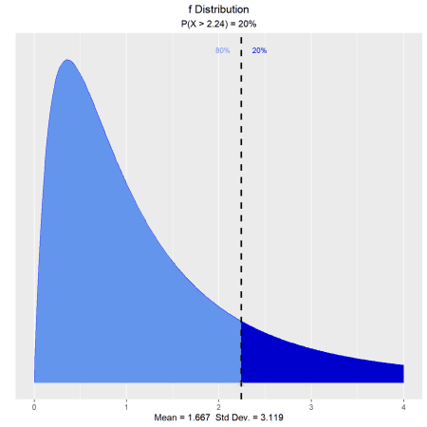

What is the 35th percentile?

vdist_f_perc(0.35, 4, 5, 'lower')

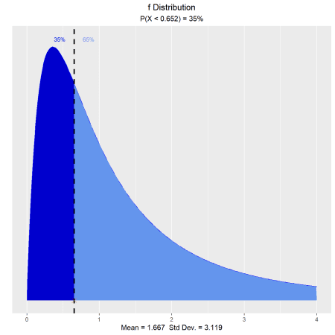

**Probabilities**

**Calculate probability from a given quantile.**

**Input**

* perc: a quantile value
* num_df: nmerator degrees of freedom
* den_df: denominator degrees of freedom
* type: lower/upper tail

What is the probability that an F random variable with 4 numerator degrees of  
freedom and 5 denominator degrees of freedom is greater than 3.89?

vdist_f_prob(3.89, 4, 5, 'upper')

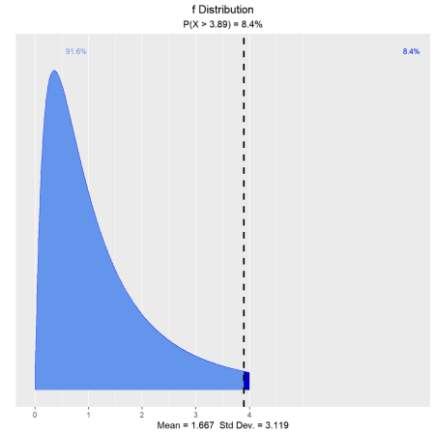

What is the probability that an F random variable with 4 numerator degrees of  
freedom and 5 denominator degrees of freedom is less than 2.63?

vdist_f_prob(2.63, 4, 5, 'lower')

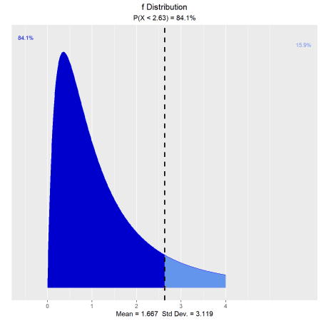

**t Distribution**

**Distribution Shape**

Visualize how degrees of freedom affect the shape of t distribution.

vdist_t_plot(df = 8)

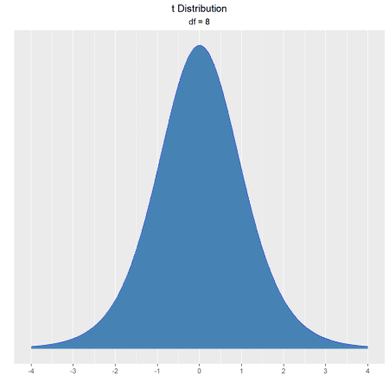

**Percentiles**

**Calculate quantiles out of given probability**

**Input**

* probs: a probability value
* df: degrees of freedom
* type: lower/upper/both tail

What is the upper fifteenth percentile?

vdist_t_perc(0.15, 8, 'upper')

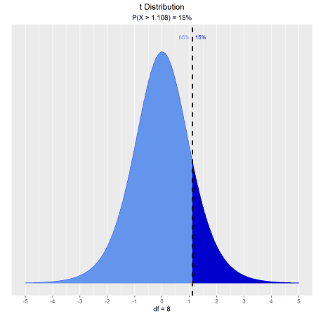

What is the eleventh percentile?

vdist_t_perc(0.11, 8, 'lower')

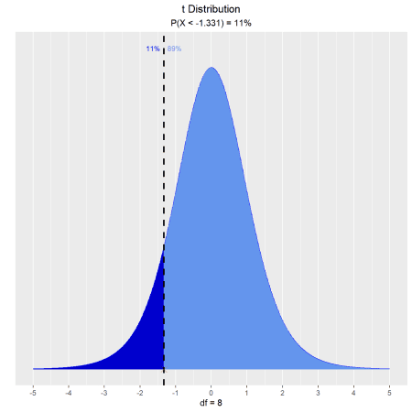

What is the area of the curve that has 95% of the t values?

vdist_t_perc(0.8, 8, 'both')

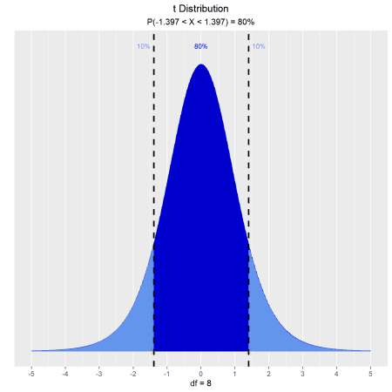

**Probabilities**

**Calculate probability from a given quantile.**

**Input**

* perc: a quantile value
* df: degrees of freedom
* type: lower/upper/interval/both tail

Let T follow a t-distribution with r = 6 df.

What is the probability that the value of T is less than 2?

vdist_t_prob(2, 6, 'lower')

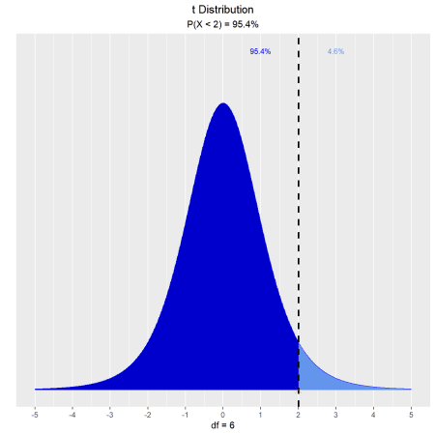

What is the probability that the value of T is greater than 2?

vdist_t_prob(2, 6, 'upper')

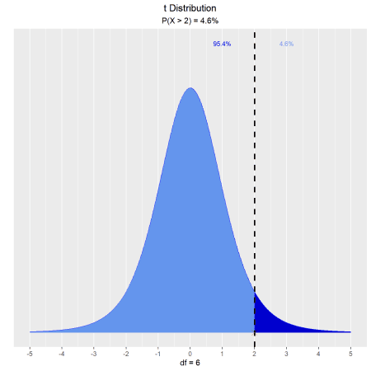

What is the probability that the value of T is between -2 and 2?

vdist_t_prob(2, 6, 'both')

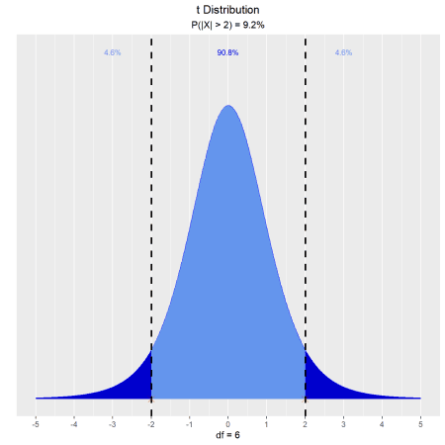

What is the probability that the absolute value of T is greater than 2?

vdist_t_prob(2, 6, 'interval')

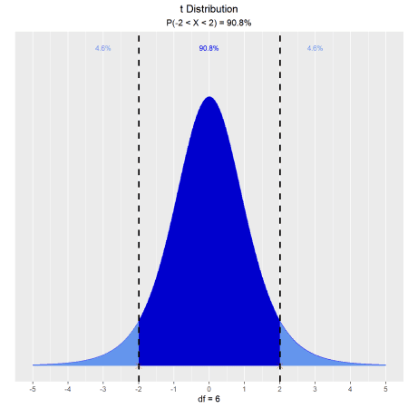

**Learning More**

The [vistributions website](https://vistributions.rsquaredacademy.com/) includes  
comprehensive documentation on using the package, including the following  
article that gives a brief introduction to vistributions: